OPERATING Systems

**Name: Girish S Roll No.: AM.EN.U4AIE22044**

--------------------------------------------------------------------------

1. **Write shell scripts for the following**
   1. **To take your name, programme name and enrolment number as input from user and print it on the screen.  
      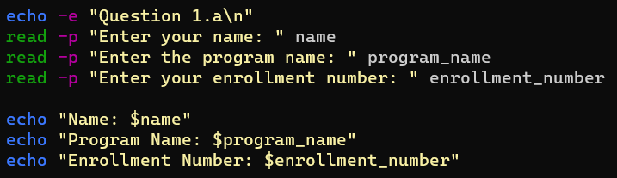  
      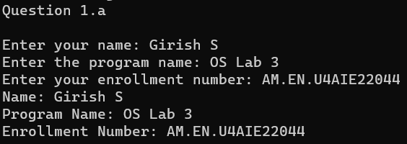**
   2. **To find the sum, the average and the product of four integers.  
      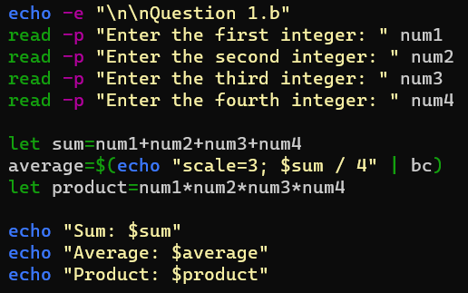**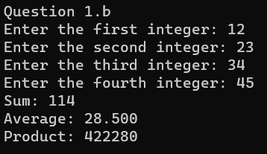
   3. **Write a program to check whether a number is even or odd.  
      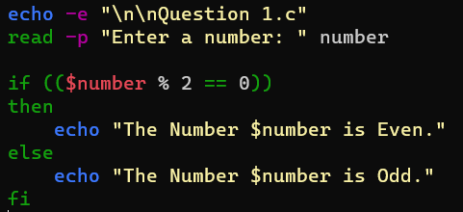  
      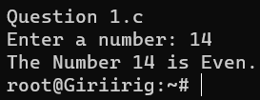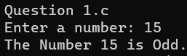**
   4. **To exchange the values of two variables.  
      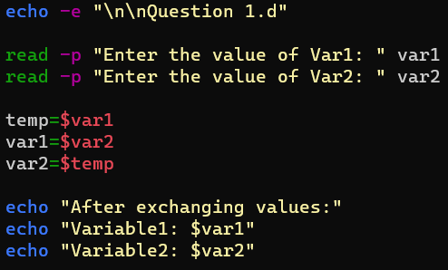  
      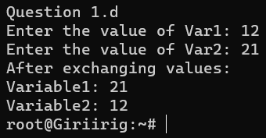**
   5. **To find the lines containing a number in a file.**